BH Workshop – 4th April 2019
BuildHealth is running a free workshop on Managing Asbestos and Dust on site. The talks will provide attendees with practical advice on how to implement controls to improve occupational health on site. There will be a demonstration on face fit testing. The workshop is suitable for site supervisors, foremen and others in control of construction work.

Event programme:

1.30 – 2.00 Registration & Refreshments
2.00 – 2.30 Introduction and BH overview – Wendy Beatty (BH Deputy Chair)
2.30 – 2.50 Managing Asbestos – David Wallace (Henry Bros)
2.50 – 3.10 Dust Control – John Evans/Pierce Kirwan (Northstone)
3.10 – 3.30 Face Fit Test Demonstration – Michael Henry (Bemac)
3.30 – 4.00 Opportunity to speak informally to Seminar speakers and HSENI Inspectors.
.

VENUE: The Belfray Country Inn
171 Glenshane Rd,
Londonderry BT47 3EN
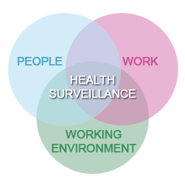
To book your place contact: Martina Kennedy, Tel: 028 9054 7075
Email: events@hseni.gov.uk

